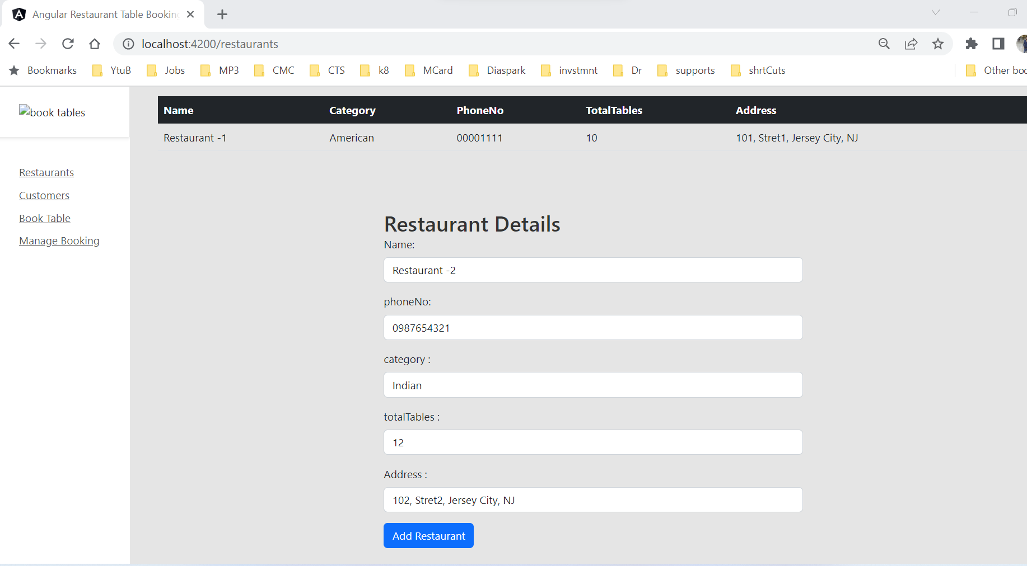

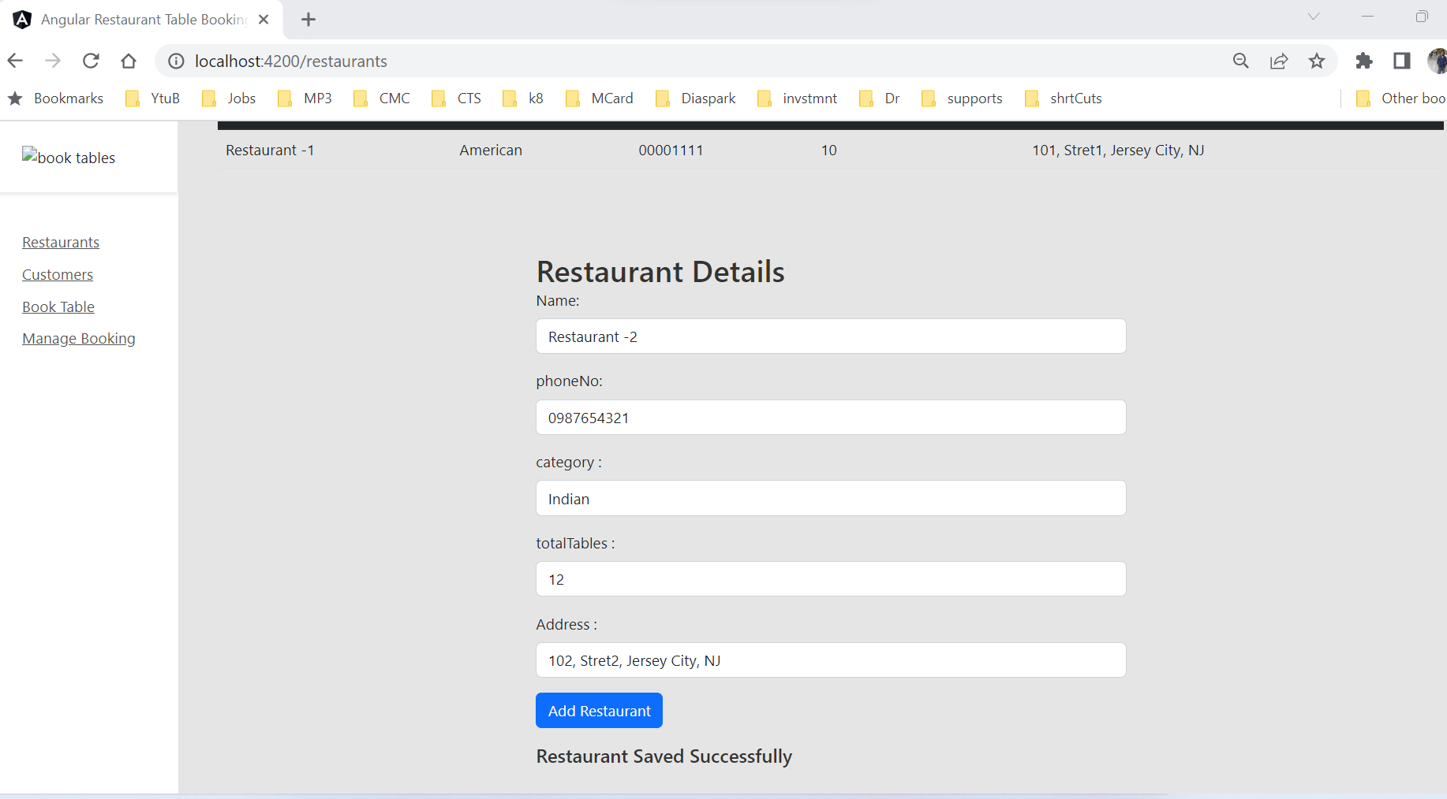

Add New Restaurant

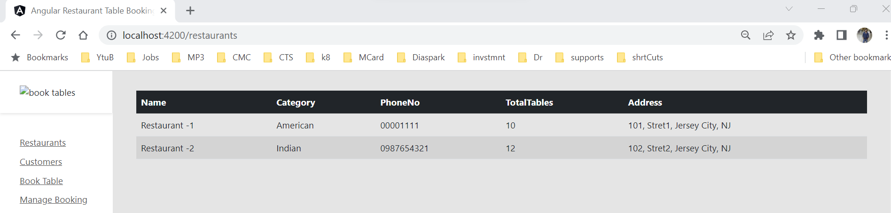

All Restaurants

New Customer screen  
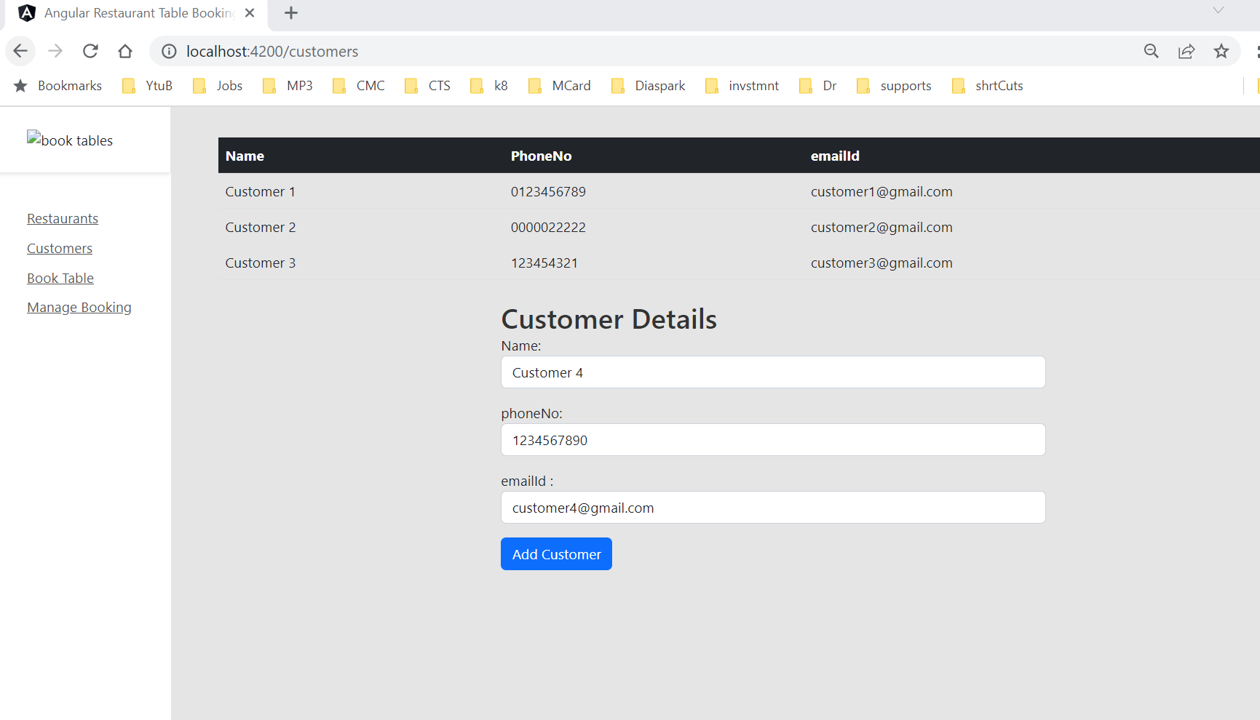

All Customers Screen

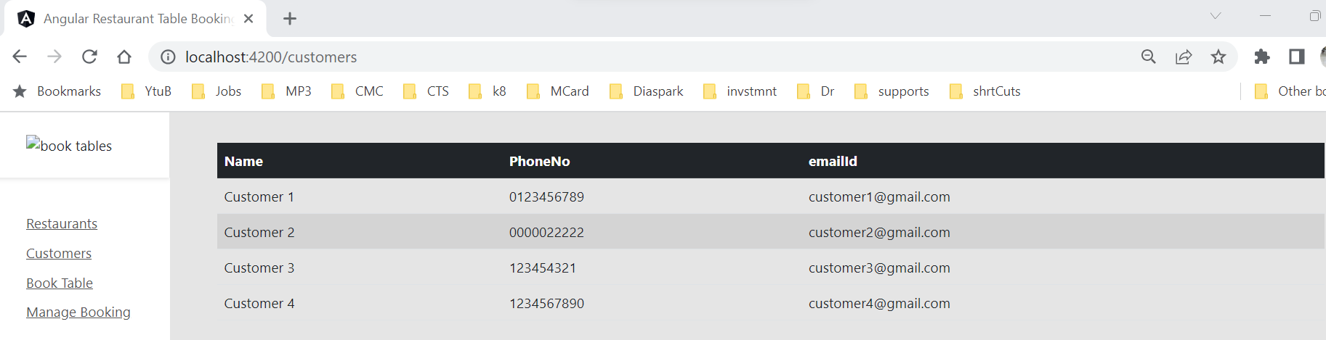

All Booking Screen

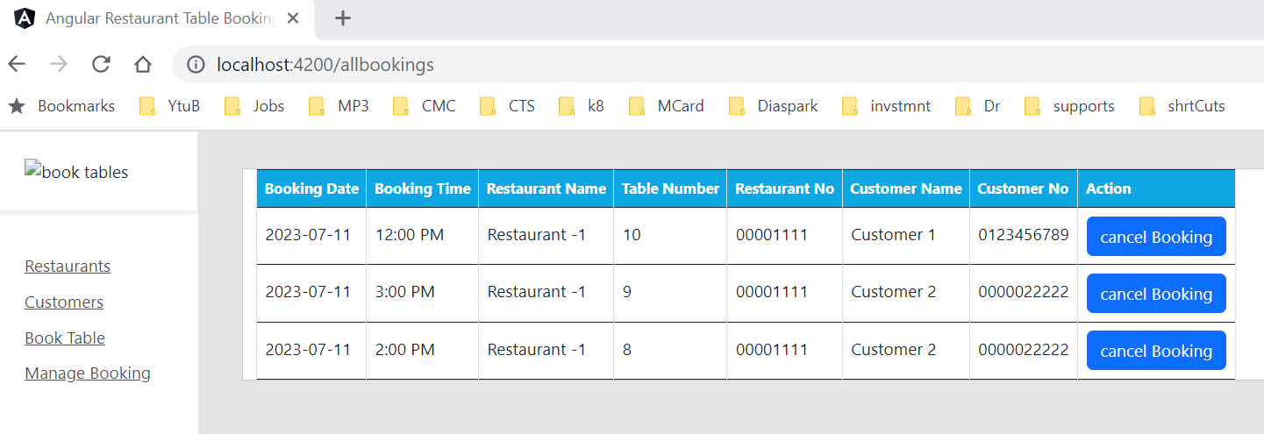

New Table Booking Screen  
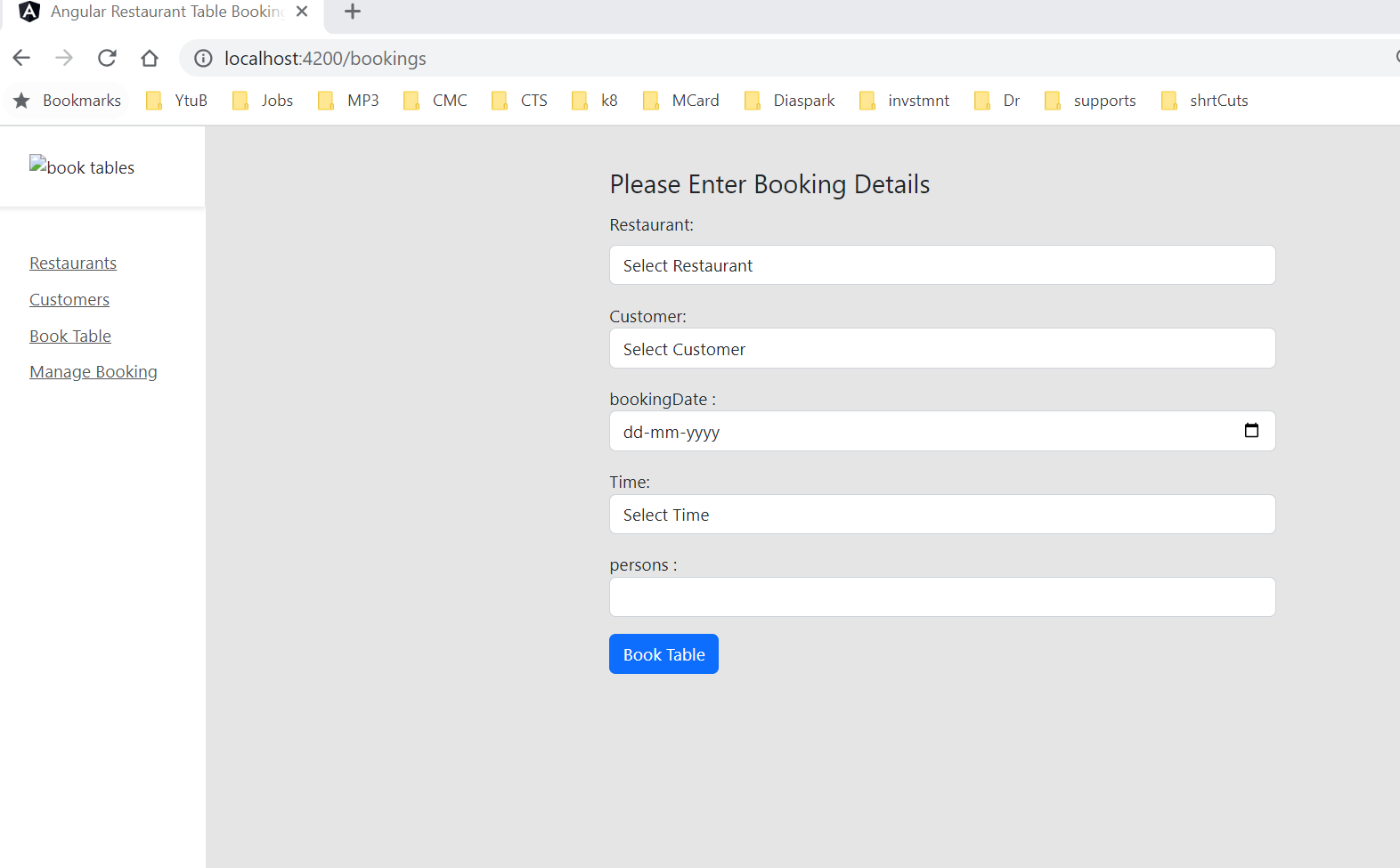

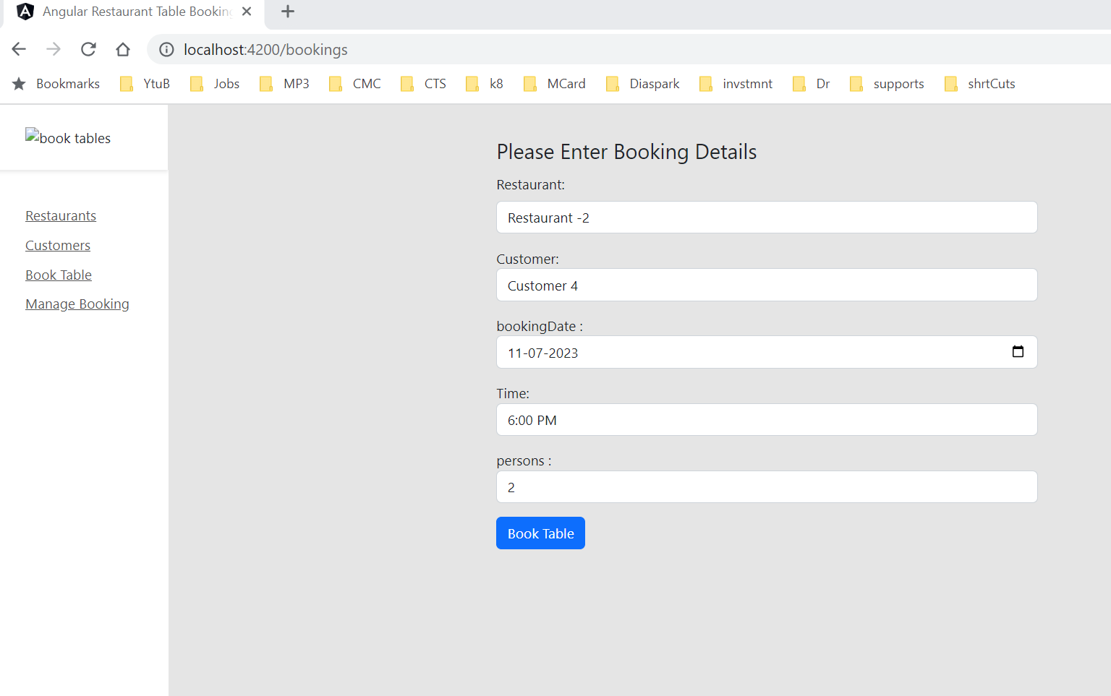

Restaurant & Customer are populating from dropdown, actual customer would be logged in customer

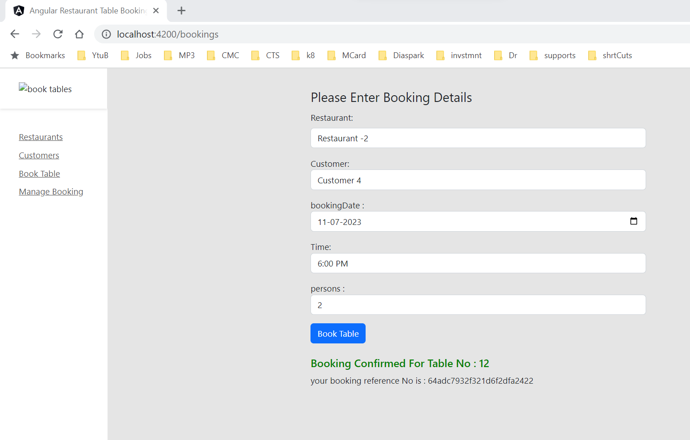

**Booking Confirm with Table No and Booking Reference Number**

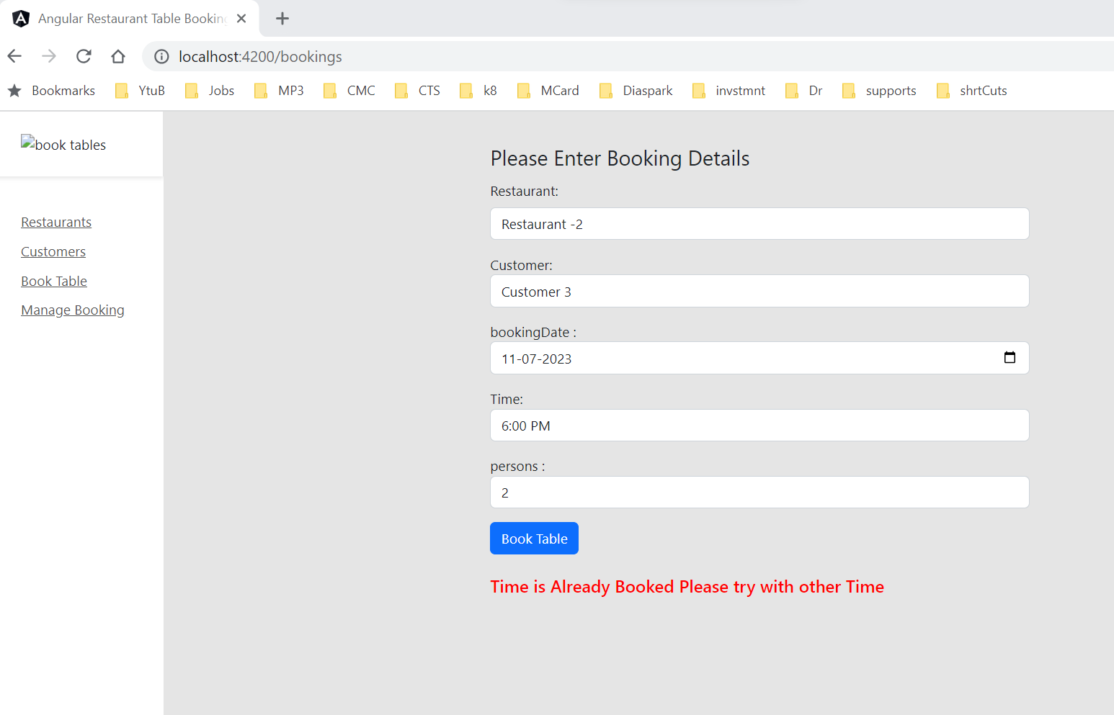

**If Same Restaurant is Trying to book at same time by Different customer it will not allowed**

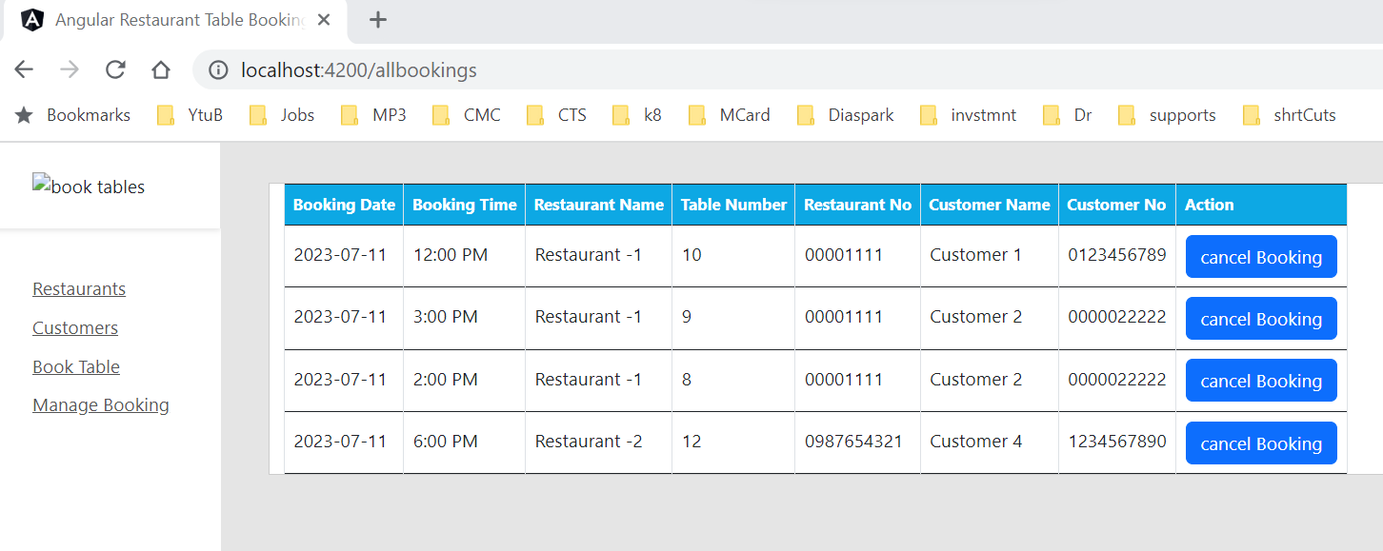

**Can cancel the Booking from here**

**\*\*\*\*\*\*\*\*\*\*\*\*\*\*\*\*\*\*\*\*\*\*\*\*\*\*\*\*\*\*\*\*\*\*\*\*\* Mongo Documents\*\*\*\*\*\*\*\*\*\*\*\*\*\*\*\*\*\*\*\*\*\*\***

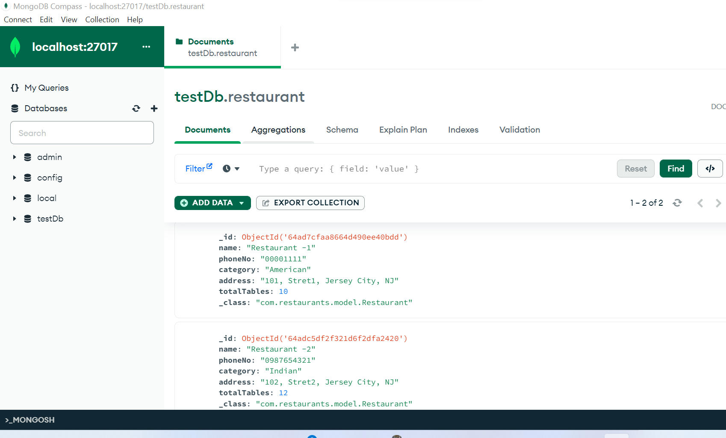

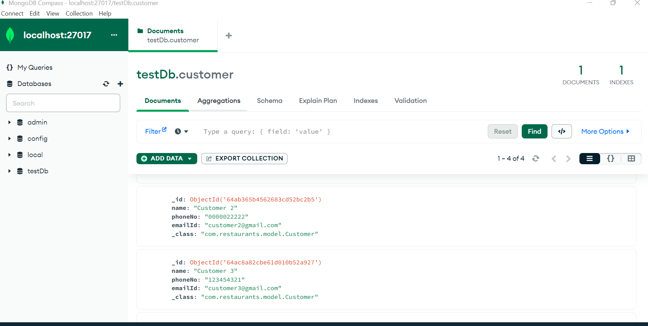

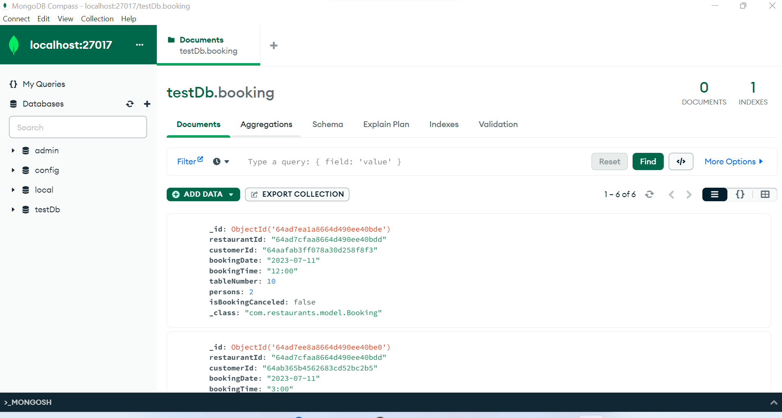

**Sample Booking schema structures**

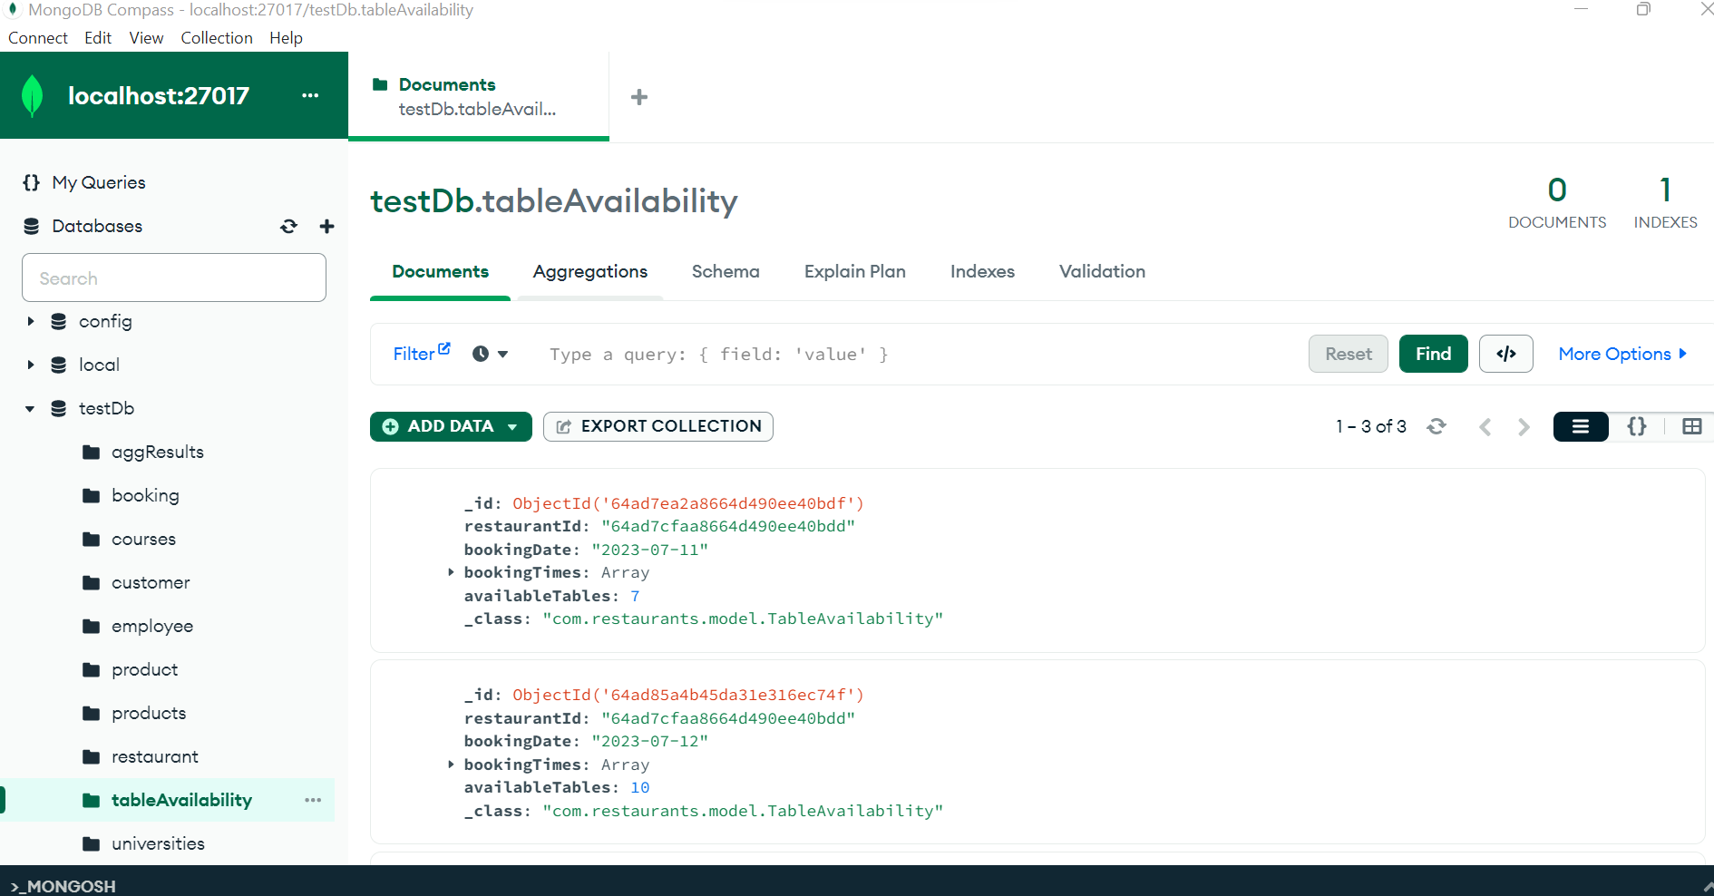

**Table Availability Reference documents**

**Junit Tests**

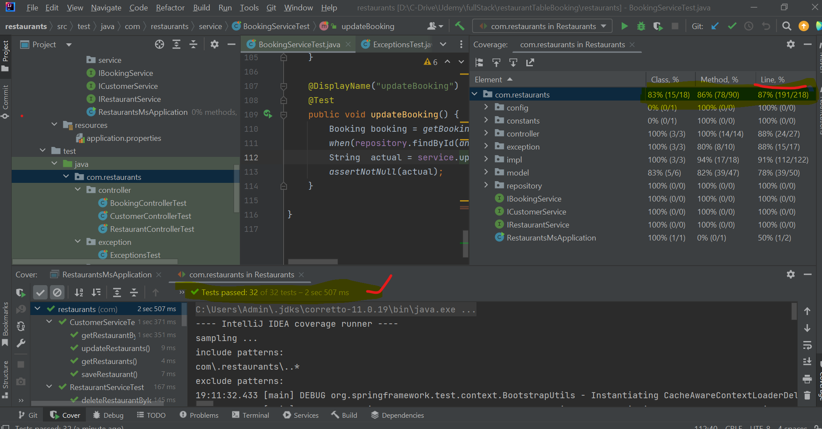

Almost all Methods are covered by Junit Test and all tests are working and Coverage is 87%